The first step is to import the MongoDB using the 'mongoimport' tool. This step ensures that the data is available for performing CRUD operations.

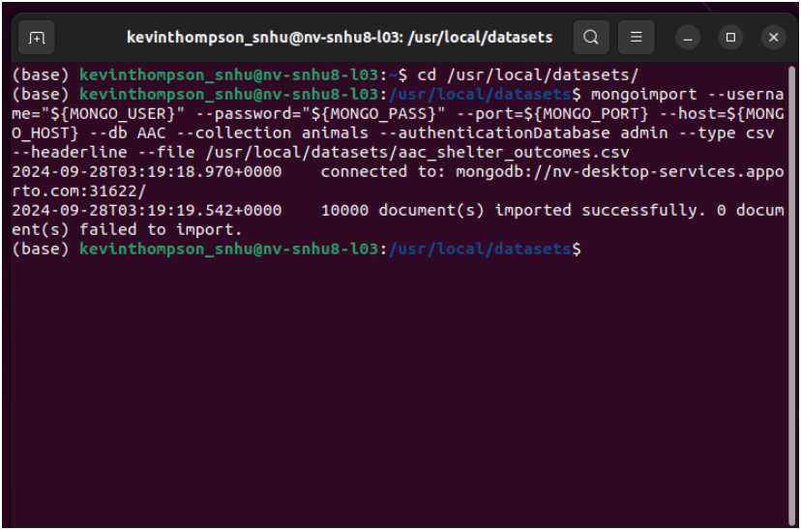

/home/kevinthompson_snhu/Desktop/AAC_Import.png

The MongoDB database is secure using user authentication. The user credentials (aacuser1) were created in the MongoDB shell to ensure secure access to the animal collection. Authentication is required when connecting to the database.

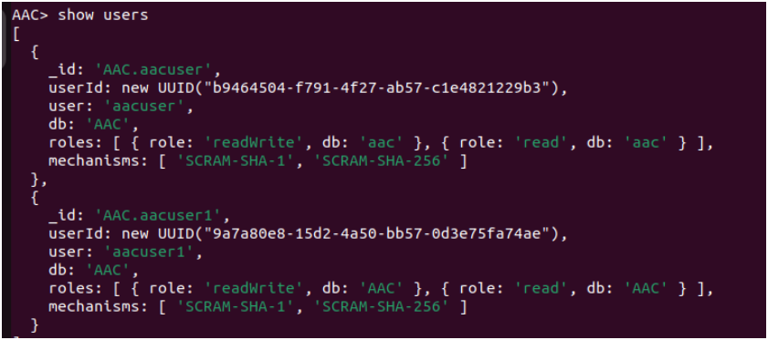

/home/kevinthompson_snhu/Desktop/User_Auth.png

The CRUD functionality test execution in the Python module:

-Create: inserts a new animal record into the database

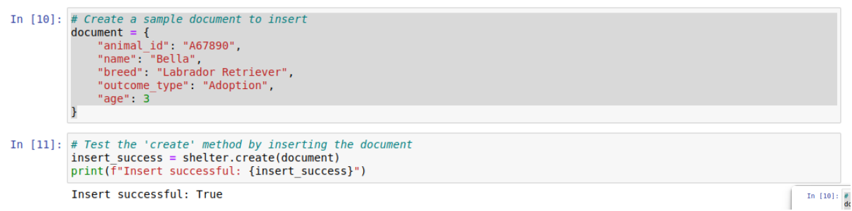

/home/kevinthompson_snhu/Desktop/AAC_CREATE.png

-Read: queried the database to retrieve the inserted record

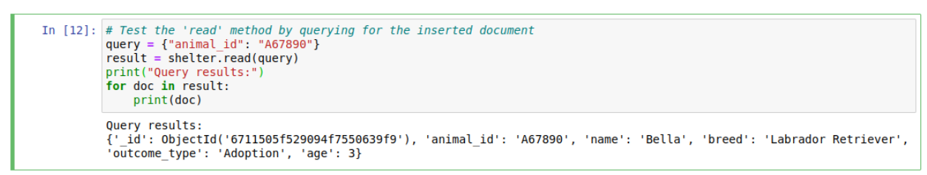

/home/kevinthompson_snhu/Desktop/AAC_READ.png

-Update: Modifies the age of the inserted animal record.



/home/kevinthompson_snhu/Desktop/AAC_UPDATE.png

-Delete: Deletes the inserted animal record.

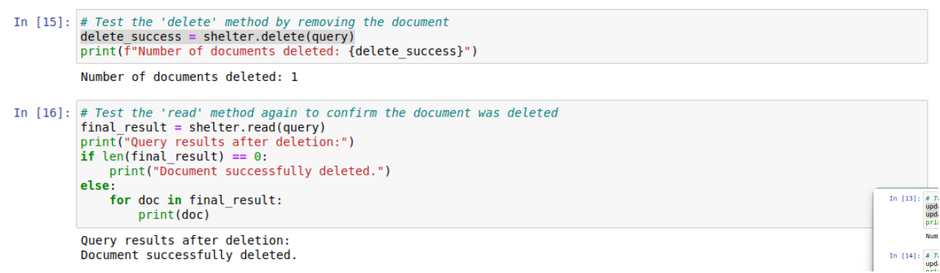

/home/kevinthompson_snhu/Desktop/AAC_DEL.png

Installation can be installed by running the following command:

pip install pymongo

Instantiating the CRUD class AnimalShelter class that connects to the MongoDB database:

from crud import AnimalShelter

# Instantiate the CRUD class

shelter = AnimalShelter()

The connection setting are predefined in the AnimalShelter class constructor.

CRUD operation overview

CREATE

- The purpose is to insert a new document into the collection by using 'create(data)'. A dictionary containing the key-value pairs representing the animal record. It should return 'True' if the insertion is successful and 'False' if it failed.

#Example:

document = {

"animal_id": "A67890",

"name": "Bella",

"breed": "Labrador Retriever",

"outcome_type": "Adoption",

"age": 3

}

READ

- The purpose is to retrieve documents matching a specific query by using 'read(query)'. A list of documents matching the query would display or an empty list if no matches are found.

#Example:

query = {"animal_id": "A67890"}

result = shelter.read(query)

UPDATE

- The purpose is to modify an existing document in the collection by 'update(query, update_data)'. The query is a dictionary specifying the document to update and update_data is specifying the fields and values to update.

#Example:

update_data = {"age": 4}

update_success = shelter.update(query, update_data)

DELETE

- the purpose is to remove documents matching a specific query from the collection by 'delete(query)'. The return should be the number of documents that are deleted.

#Example:

delete_success = shelter.delete(query)